Git Extensions installation in MAC

- Ensure that git is already installed in MAC.
- Download mono – MDK from http://www.mono-project.com/download/

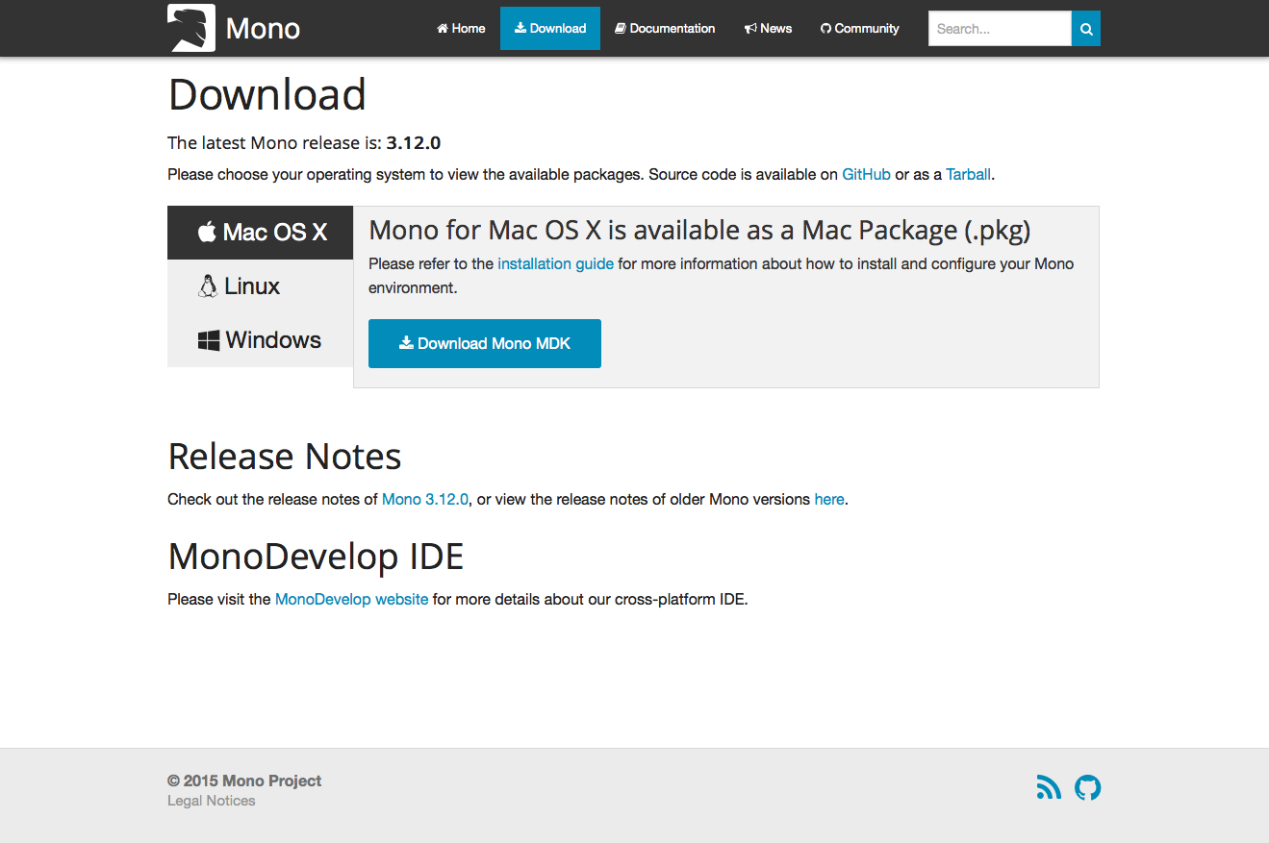
- After you have completed the download, you will see a .dmg file. Double click it to open the package.
- Inside the .dmg file you will have MonoFramework-{version}.pkg. Double click to start the installation process.
- Follow the wizard until it’s completion.
- If everything went okay, you should open your terminal and check mono version:
$ mono –version
Mono JIT compiler version 3.8.0 (mono-3-8/2baeee2 Wed Jan 16 16:40:16 EST 2013)
Copyright (C) 2002-2012 Novell, Inc, Xamarin, Inc and Contributors. www.mono-project.com
TLS: normal
SIGSEGV: normal
Notification: kqueue
Architecture: x86
Disabled: none
Misc: softdebug
LLVM: yes(2.9svn-mono)
GC: Included Boehm (with typed GC)

- Now download Git Extensions latest version from https://sourceforge.net/projects/gitextensions.
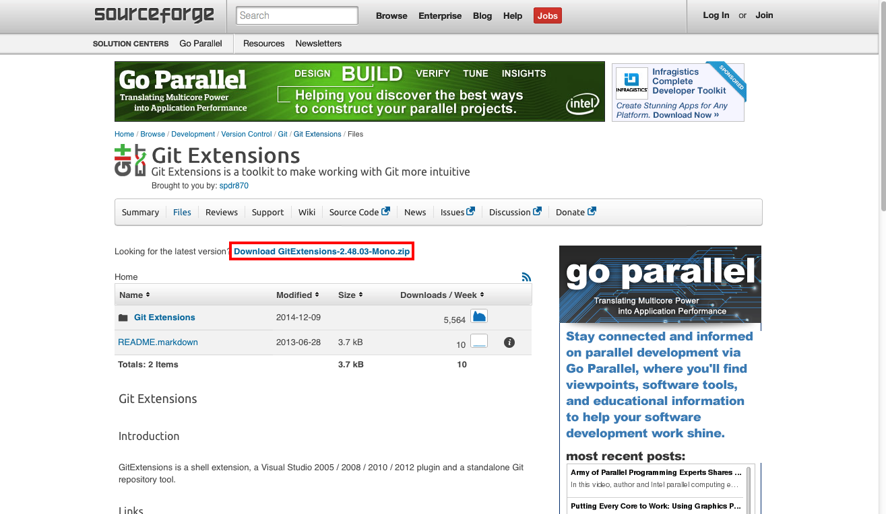
- Now extract the above downloaded zip folder .
- Browse into the folder where you extracted the package and just run mono command, like the example below:
$ mono GitExtensions.exe

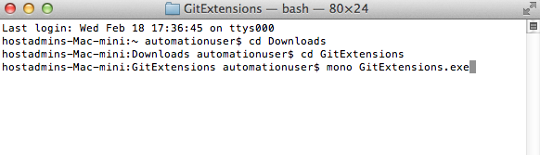

Troubleshooting Mac Installation
- If your Git Extensions crashes with an exception that a font is missing (generic sans serif), you probably can fix this by installing Xquartz. This is a version of the X.Org X Windows System that runs on OS X. I am not sure what the side effects are. This can be installed from here: http://xquartz.macosforge.org/landing/
- If Git Extensions still crashes because it is unable to load a plugin, empty the plugins folder.

Following is displayed after running gitextensions from terminal

